2024年南區胸腔病例討論會
2024 Chest case discussion
課程表
地 點：阮綜合醫院 B棟十樓大教室
地 址：高雄市苓雅區成功一路162號 連絡人：
內科部曾玲雯07-3351121#3075
林莞茹專科護理師07-3351121#2258
場次 | 會議日期 | 時間 | 主持人
1 | 2024年11月13日 | 15:00〜17:00 | 蕭惠元、楊明泉等
2 | 2024年12月11日 | 15:00〜17:00 | 蕭惠元、楊明泉等

主持人
胸腔內科 胸腔外科
蕭惠元 醫師  現職：胸腔內科主任  學歷：  經歷：  阮綜合醫院胸腔科主任 | 楊明泉 醫師  現職：胸腔外科主治醫師  學歷：高雄醫學院醫學系畢業  經歷：  高雄醫學院外科學講師兼胸腔食道外科  心臟血管外科主治醫師、呼吸治療科主治醫師兼主委  阮綜合醫院胸腔血管外科主治醫師兼主任  阮綜合醫院急救加護病房主治醫師兼主任  阮綜合醫院外科部部主任  國立成功大學外科學講師兼胸腔外科主治醫師
  國防醫學院醫學系醫學士
  國立高雄師範大學事業經營學系碩士
  高雄榮民總醫院內科部住院醫師、總醫師
  高雄榮民總醫院胸腔內科總醫師、主治醫師
  高雄榮民總醫院屏東分院胸腔內科主治醫師
梁宇峰 醫師  現職：胸腔內科主治醫師  學歷：高雄醫學院醫學士  經歷：  高雄醫學院醫師  縣立鳳山醫院主治醫師  阮綜合醫院胸腔科主任 | 林鴻生 醫師  現職：胸腔外科主任  學歷：國立陽明大學醫學系畢業  經歷：  高雄榮民總醫院胸腔外科主治醫師  台灣外科醫學會會員  胸腔及心臟血管外科醫學會會員  胸腔暨重症加護醫學會會員
王瑞隆 醫師  現職：胸腔內科主治醫師  學歷：台北醫學大學 醫學系  經歷：  台北馬偕醫院內科住院醫師  林口長庚醫院胸腔科主治醫師  高雄長庚醫院胸腔內科主治醫師  高雄長庚醫院胸腔內科主任  台灣胸腔暨重症加護醫學會理監事 | 戴碩瑩 醫師
  現職：阮綜合醫院胸腔外科主治醫師
  學歷：國立成功大學醫學系
  經歷：
  成功大學醫學院附設醫院胸腔外科總醫師
  台灣外科醫學會專科
  台灣胸腔及心臟血管外科專科
  台灣肺癌醫學會專科
林安伸 醫師
現職：胸腔內科主治醫師
學歷：中國醫藥大學醫學系
經歷：
林口長庚紀念醫院內科部住院醫師
長庚紀念醫院胸腔內科總醫師
高雄長庚醫院胸腔內科主治醫師
2024年南區胸腔病例討論會
2024 Chest case discussion
課程表
地 點：阮綜合醫院 B棟十樓大教室
地 址：高雄市苓雅區成功一路162號 連絡人：
內科部曾玲雯07-3351121#3075
林莞茹專科護理師07-3351121#2258
場次 | 會議日期 | 時間 | 主持人
1 | 2024年11月13日 | 15:00〜17:00 | 蕭惠元、楊明泉等
2 | 2024年12月11日 | 15:00〜17:00 | 蕭惠元、楊明泉等
場次1
15：00-15：30討論病例
Name: 蔡XX
Age : 81-year-old
Gender: male
Chart NO: 10xxx15
C/C :
Chest tightness in last night
Past history :
1.Hypertension:(-)
2.Type II diabetes mellitus:(+) OHA control for years
3.Hyperlipidemia:(-)
4.Hepatitis-B(-),Hepatitis-C(-)
5.Past history of special systemic disease: Denied.
6.Genetic disorder:(-)

- Operation/ admission history:
Coronary artery disease with 2 vessel disease post percutaneous coronary intervention with stent for LAD & LCX.(98-3-10) with regular treatment at our hospital
- Allergy history.
Drug allergy:Denied
Denied food allergy (Seafood, Broad bean, Peanut, Shrimp, Crab)

Family history:
-Denied type II diabetes mellitus
-Denied hypertension
-Denied genetic
-Denied malignant disease
-Denied urolithiasis

個人病史：
[Personal History]-->
Education: illiteracy
Marital status: divorce
Exercise: occasional
Alcohol: No
Tobacco: regular
Coffee: occasional
Tea: occasional
Betel nut:no

T: travel history: denied. in recent three months
O: occupational hitory: retired
C: contact history: denied
C: cluster history: no family and friend with the similar symptoms.

理學發現：
[Vital Sign]
--> BH:165cm ; BW:67.0kg ; Temp:37.4C ; BP:96/62 mmHg
PR:125 /min RR:21 /min
[General appearance]
--> Consciousness:alert GCS:(E4V5M6 )
Development:normal
Nourishment:well
[Ear]
--> EEC:clear
Hearing:normal
[Throat]
--> Tonsil:normal
Tongue:normal
Pharynx:normal
[Nose]
--> Discharge:no
Smelling:normal
[Thyroid]
--> Size:non-palpable
Nodule:non
[Eye]
--> Conjunctiva: not anemic
Sclera: not icteric
Pupil size, R't: 3mm Pupil size, L't: 3mm
Light reflex (R/L):+/+ Shape:regular
[Lymph Node]
--> Cervical:non palpable
Axillary:non palpable
Inguinal:non palpable
Consistency: soft
[Chest]
--> Contour:normal
Percussion:reasonant
Breathing sound: crackles
Heart beat:regular
Heart sound:no murmur
[Abdomen]
--> Liver: non palpable
Spleen: non palpable
Mass:no
Tenderness:RLQ
Bowel Sound: hypoactive
Rigidity:non
Ascites:non
Distension: mild
Hernia:normal
[Spine & Extremities]
--> Spine:normal
Upper extremities:normal
Lower extremities:normal
Nail:normal

入院經過:
This 81-year-old man had suffered from Chest tightness in last night, he come to our ER for help. At our ER, check SpO2:88% gave O2 simple mask 10 L/min use. F/U lab data showed 2023/04/26 -> WBC=24.8; Hb=15.1; Hct=45.4; Platelet=281; K=3.9; Cre(B)=0.76; GPT(ALT)=14; Bil(T)=1.12; Troponin I(AMI≧500pg/mL)=65.1; SARS-CoV-2 Antigen Rapid Test=Negative; PT=12.9; PT (INR)=1.19; PT (Ctrl)=10.9; APTT=34.5; APTT (Ctrl)=29.3; pH=7.375; pCO2=43.8; pO2=22.5; HCO3std=22.7; BE ecf=-0.2; due to WBC high then gave Cefoperazone-Sulbactam inj. 2g/vial(Brosym) 4000mg Q12H use. due to fever 38 then gave ACETAMINOPHEN 500mg (PARAN) 2tab po ST. F/U CXR showed Right hilar mass with suspected mediastinal lymphadenopathy. arrange F/U Chest CT showed 1. In favor of lung cancer in the right upper lobe with right supraclavicular and bilateral mediastinal lymph node metastases and liver metastasis. T4N3M1b. 2. Centrilobular emphysema in both lungs, especially in both upper lobes. Under the impression of Lung mass, susp lung ca with obstructive pneumonia, he admitted to our MICU for further treatment.
一般檢查：
2023/04/27 -> PSA=2.5 ng/ml; CEA=8.8 ng/ml; AFP=3.4 ng/ml;

特殊檢查及處置：
@.2023/4/26 Chest CT-With Contrast
1. In favor of lung cancer in the right upper lobe with right supraclavicular and bilateral mediastinal lymph node metastases and liver metastasis. T4N3M1b.
2. Centrilobular emphysema in both lungs, especially in both upper lobes.
3. Atherosclerosis of coronary arteries.
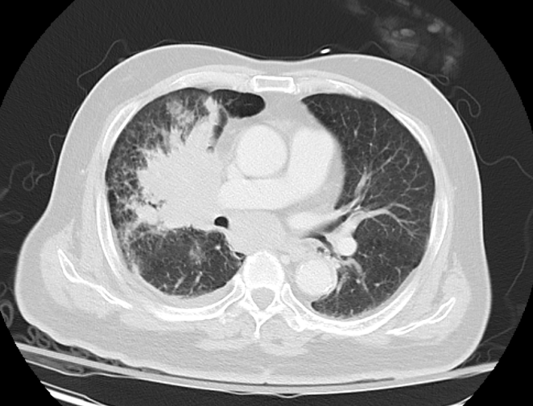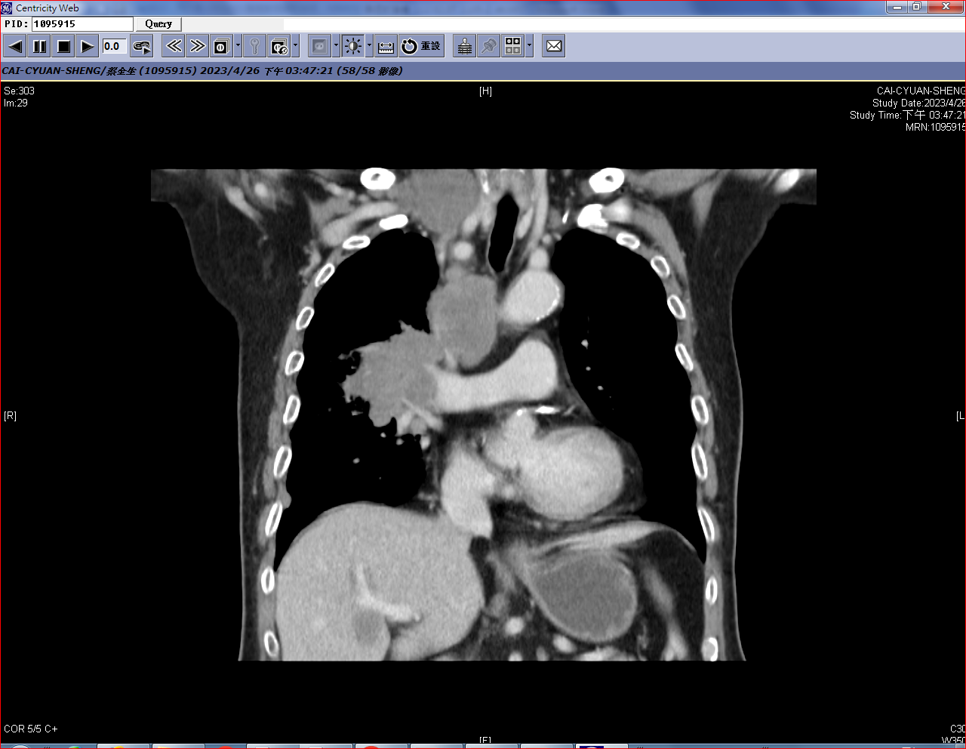
@.2023/4/29 MRI of head:
1.Right thalamic and left posterior middle pontine old presumed launar infarcts favored.
2.Left SCA territorial old small infarcts favored.
3.Bil. frontotemporoparietal cortical atrophy.
4.Bil. posterior fossa subdural effusions suspected.
5.Bil. frontoparietal subcortical few ischemia-related gliotic foci.
6.Basilar dolichoectasia with dissection.

手術日期及方法：
@. Operation: Incisional biopsy over right supra-clavicular lymph node on 2023/04/27

病理報告：
@.2023/04/28 PATHOLOGIC DIAGNOSIS:
Metastatic small cell carcinoma --- lymph node, right supra-clavicular, incisional biopsy
MICROSCOPIC EXAMINATION:
The sections of the specimen show a picture of soft tissue with metastatic small cell carcinoma, consisting of solid nests of small neoplastic epithelial cells with hyperchromatic nuclei, inconspicuous nucleoli, and scanty cytoplasm. Foci of necrosis and crush artifact are also present. By immunohistochemical stain, the tumor cells are positive for TTF-1, synaptophysin, and CD56, negative for chromogranin A, and p40.
Adequate tumor cells present (>=100 viable tumor cells): Yes
治療經過:
This 81-year-old man had suffered from chest tightness last night, he come to our ER for help. At our ER, check SpO2:88% gave O2 simple mask 10 L/min use. F/U lab data, WBC high(WBC=24.8) then gave Brosym 4000mg q12h use. CXR showed lung mass on right lobe, therefore arrange chest CT showed(1)In favor of lung cancer in the right upper lobe with right supraclavicular and bilateral mediastinal lymph node metastases and liver metastasis, T4N3M1b. (2)Centrilobular emphysema in both lungs. Under the impression of Lung mass,suspect lung cancer with obstructive pneumonia,he admitted to our MICU for further treatment.
In ICU, O2 support use, IV fluids hydration, on oral DM diet 1300 K/day, Methylprednisolone inj. 40mg q12h, appropriate antibiotics with Tazocin inj. 4500mg q8h for pneumonia and Bronchodilator with Atrovent sol'n inhalation q12h were prescribed.
After Thoracic Surgeon Dr.林鴻生 full explained, he received operation of incisional biopsy over right supra-clavicular lymph node under LA on 04/27. Patient and dhis families ask for discharge, suggest transfer to general ward first, his families sign DNR (drug only) on 04/28. Now, GCS:E4V5M6, on O2 Venturli mask 40%12L/min use, wound dry and clean, not oozing, kept antibiotics treatment, then transfer to general ward on 2023/04/28. At ward, keep monitor clinical symptoms and conditoin.Arrange head MRI without contract on2023/04/29 ,show 1.Right thalamic and left posterior middle pontine old presumed launar infarcts favored.2.Left SCA territorial old small infarcts favored.waiting biopsy report ,With overall condition stable patient was discharged and regular OPD follow up prescribed.

15：30-16：00討論病例
Name: 吳XX
Age : 53 year-old
Gender: male
Chart NO: 16xxx59
C/C :
persistent cough with severy sputum for 4 weeks
Past history :
1.Diabetes mellitis (-)
2.Hypertension (-)
3.Heart disease (-)
4.hepatitis b or C (-)
5. Schizophrenia, unspecified ( without follow-up )
6.Operation : nil
Operation history : Nil
Allergy history:
1. Drug allergy: Denied
家族史：
Family history:
- Month : nil
- Heart disease: nil
- Renal disease: nil
- HBV/HCV: nil
- Pulmonary disease: nil
- Cancer : nil
- Hypertension: nil
- Diabetes Mellitus: nil
個人病史：
[Personal History]-->
Education:junior-high
Marital status: Married
Exercise:no
Alcohol:daily
Tobacco: 3/2PPD for 20+years
Coffee: no
Tea: occasional
Betel nut: no
TOCC:
T: travel history: denied. in recent three months
O: occupational hitory: denied
C: contact history: denied
C: cluster history: denied
理學發現：
[Vital Sign]
--> BH:171.5cm BW:.71.5kg
Temp:36.8C BP:154/79mmHg
PR: 82/min RR:18 /min
[General appearance]
--> Consciousness:alert GCS:(E4V5M6 )
Development:normal
Nourishment:well
[Ear]
--> EEC:clear
Hearing:normal
[Throat]
--> Tonsil:normal
Tongue:normal
Pharynx:normal
[Nose]
--> Discharge:no
Smelling:normal
[Thyroid]
--> Size:non-palpable Nodule:non Tender: -

[Eye]
--> Conjunctiva: not anemic
Sclera: not icteric
Pupil size, R't: 2mm Pupil size, L't: 2mm
Light reflex (R/L):+/+ Shape:regular
[Lymph Node]
--> Cervical:non palpable
Axillary:non palpable
Inguinal:non palpable
Consistency:soft
[Chest]
--> Contour:normal
Percussion:reasonant
Breathing sound: clear
Heart beat:regular
Heart sound:no murmur
[Abdomen]
--> Liver: non palpable
Spleen: non palpable
Mass:no
Tenderness:no
Bowel Sound: Clear
Rigidity:non
Ascites:non
Distension:no
Hernia:normal
[Spine & Extremities]
--> Spine:normal
Upper extremities:normal
Lower extremities:normal
Nail:normal
入院經過:
A 53-year old male paient was a case of well being before.
He suffered from persistent cough with severy sputum for 4 weeks , he came to local clinic but symptoms persisted; no fever or chills during this time, The past few days cough , purulent sputum more and more obvious , he visited our chest OPD on 2023/05/08 follow up Chest x-ray showed An cavity in right upper lung , increased infiltration ocer bilateral lung field, heart size normal ,then was suggested to admit. The physical examination and associated symptoms included Chest breath sound: coarse in bilteral lung field; Heart sound: regular without murmur.the Fever, cold sweating, myalgia, short of breath, chest tightness, chest pain, poor appetite, nausea, body weight loss, vomiting, flank pain, dysuria were not found.Under the impression of r/o pulmonary tuberculosis or malignanacy , he was admitted to isolation ward for further evaluation and management.
After admission, he received antibiotics Cefazolin inj. 1g q8h therapy one dose on 05/10 for r/o pneumonia. Bronchodilator and Anti-tussive agents was given for symptom relief. Arrange Chest CT without contrast Findings: RUL central-located malignancy is suspected with bronchial obliteration, small pleural effusion and bilateral mediastinal lymphadenopathy; Tentative staging: T4 N3 M1a.
And Sputum Acid-Fast Stain showed No AFB observed, from isolation room transfer the patient to chest ward for further study. Tissue diagnosis is recommended, Arrange Bronchoscopy : Bilateral main bronchus and bronchi：multiple small nodules at both bronchus; mass at right upper bronchus spread to bification of upper low bronchus, biopsy was done from: R1+2+3. Bronchial Brushing cytologic: Positive for malignant cells, compatible with non-small cell carcinoma of lung. Arrange Brain MRI and Bone scan for evaluation as lung cancer clinical guideline. The whole body bone scan revealed increased uptake of radioactivity in the L5 spine and lateral aspect of right 7th rib. Two bone metastases in the L5 spine and right 7th rib should be excluded first. Suggest further evaluation. No evidence of intracranial tumor growth.
He complaints of increased cough and severe cough with chest pain, for better pain control: discontinues of TramaCET and shift to Fentanyl patch 25mcg/h 1patch q3d used. Due to suffered from nausea and vomiting, stop Fentanyl patch 25mcg , changed to Tramadol-Acetaminophen 37.5/325mg 1# qid + Acetaminophen 0.5# qid/po to pain control.
On 05/17 bronchoscopic biopsy showed Adenocarcinoma of bronchus; The tumor cells have hyperchromatic and pleomorphic nuclei. In the immunohistochemical study, TTF-1 is positive while p40 is negative. EGFR, PDL-1 and ROS-1 examinations study was arranged (05/18). stable condiction, he discharged today and followed-up at OPD.
一般檢查：
 | 2022/05/10
CEA | 6.6 | ng/ml
SCC | 1.0 | ng/ml
特殊檢查及處置：
2023/5/8 醫令名稱: Chest PA View Standing
Air space infiltration in the right lung, consistent with pneumonia.
Recommend follow up study.
Right paratracheal space widening, R/O lymphadenopathy.
Cardiomegaly.
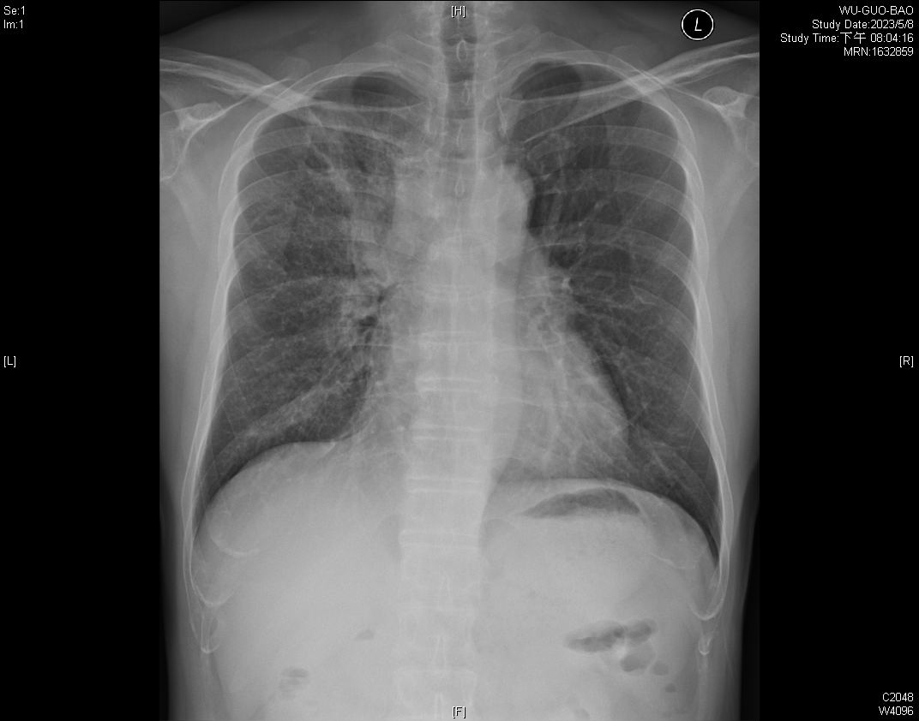
2023/5/10 醫令名稱: Chest CT-Without Contrast
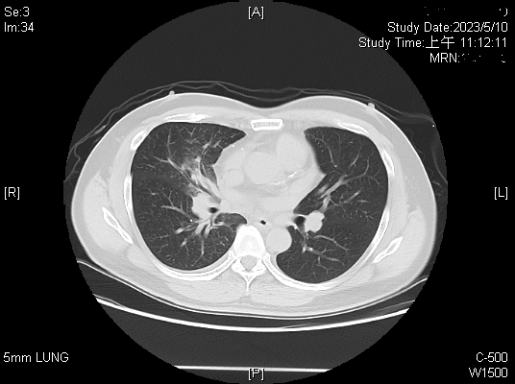
Findings--
Lung : Right upper perihilar mass-like opacity(7.8cm) with bronchial obliteration. Peribronchial infiltration in the right middle lobe.
Pleura : Small right pleural effusion.
Trachea and main bronchi : Obliteration of the RUL bronchus. Narrowing of the right intermediate bronchus.
Mediastinal lymph node : Bilateral mediastinal lymphadenopathy.
Musculoskeletal system : Spondylosis.
Impression--
RUL central-located malignancy is suspected with bronchial obliteration, small pleural effusion and bilateral mediastinal lymphadenopathy
-- Tentative staging: T4 N3 M1a
-- Tissue diagnosis is recommended.

2023/5/17 醫令名稱: NM 060-Bone scan
Clinical：Lung cancer for staging
《Imaging Findings》
The bone scan was performed 2 hrs after given 20 mCi of Tc-99m MDP (i.v.). The whole body bone scan revealed increased uptake of radioactivity in the L5 spine and lateral aspect of right 7th rib.
《Impression》
Two bone metastases in the L5 spine and right 7th rib should be excluded first. D/D: trauma or others. Suggest further evaluation.

2023/5/13 醫令名稱: Abdominal ultrasound
Chief Complaint :Persistent cough with severy sputum for 4 weeks
Finding:
Liver :Normal liver size, smooth hepatic surface, but sl heterogenous liver parenchymal c moderate increase liver-kidney contrast, smooth vessels. One strong hyperechoic spot(0.36cm) c acoustic shadow noted at S5, favor calcification or others.
GB :Multiple strong hyperechoic spots(0.20~0.40cm) with and without acoustic shadow noted in GB, favor GB stones and polyps, wall thickening(-), no probe Murphy's sign.
Pancreas :Head and body: np, tail masked by air.
Kidney :Mild increase echogeneicity of bil renal cortex and medulla.
Diagnosis:1.Diffuse liver dz c moderate fatty change.
2.Hepatic calcification, Rt lobe.
3.GB stones and polyps.
4.Bil renal parenchymal dz.

2023/5/11 醫令名稱: Bronchoscopy
.Bilateral main bronchus and bronchi：
multiple small nodules at both bronchus; mass at rt upper bronchus spread to bification of upper low bronchus
1.Bronchial brushing and washing were done from：R1+2+3
2.Biopsy was done from：R1+2+3

2023/05/11 -> Bronchoscopic biopsy : Adenocarcinoma ----
GROSS EXAMINATION:
The specimen submitted consists of two tissue fragments measuring up to 0.2 x 0.1 x 0.1 cm in size fixed in formalin. Grossly, they are tan and soft.
All for section.
MICROSCOPIC EXAMINATION:
The section shows bronchial tissue with infiltrating neoplastic epithelial cells focally forming irregular glandular structure in a fibrotic stroma. The tumor cells have hyperchromatic and pleomorphic nuclei. In the immunohistochemical study, TTF-1 is positive while p40 is negative.
* More than 100 tumor cells are present in the specimen.

2023/05/31-> PDL-1
Tumor location: Bronchus
Testing assay: 22C3
Result:
1. Tumor Proportion Score (TPS) category:
[ ] TPS ＜ 1%
[ ] TPS ＞=1% and ＜50%
[ V ] TPS ＞= 50%
2. Tumor Proportion Score (TPS): 99 %
DX :
Adenocarcinoma of RUL with bronchial obliteration, small pleural effusion and bilateral mediastinal lymphadenopathy, tentative staging: T4 N3 M1a
P: Target therapy : #Iressa 250mg/tab[Gefitinib] 1# qd on 05/23~

16：00-16：30討論病例
Name: 龍 XX
Age : 54 year-old female
Chart NO: 59xx02
C/C : chronic cough over 6 months
Past history :
1. Type 2 diabetes mellitus was regular follow up at LMD
2. Arrhythmia was regular follow up at LMD
3. Hyperlipidemia was regular follow up at LMD

Op history: denied
- Cesarean section x 2 (33 and 28 years ago)

家族史：
Denied hypertension, Diabetus Mellitus and cancer history of parents

旅遊史：
TOCC
Travel history in recent 3-6 months ago: denied
Occupation: Housewife
Contact history: Animal contact history: nil, Illness contact history: nil
Cluster: no family and friend with the similar symptoms

個人病史：
[Personal History]--> Occupation:Housewife
Education:junior-high Marital status:married Exercise:no
Alcohol:no Tobacco:regular Coffee:no Tea:no
Betel nut:no Drugs:Anti-H/T Allergy:never Denied 動物接觸史:無

理學發現：
[Vital Sign]--> BH:163 cm BW:58.7 kg Temp:36 度C BP:139/85 mmHg
PR:98 /min RR:20 /min
[General appearance]--> Consciousness:alert GCS:(E4V5M6 ) Development:normal Nourishment:well
[Ear]--> EEC:clear
[Throat]--> Tonsil:normal Tongue:normal Pharynx:normal Mouth floor:normal
[Nose]--> Discharge:no
[Thyroid]--> Size:non-palpable Nodule:non
[Eye]--> Conjunctiva:pink Sclera:not icteric Pupil size, R't:2mm Pupil size, L't:2mm Light reflex (R/L):+/+
[Lymph Node]--> Cervical:non palpable Axillary:non palpable Inguinal:non palpable
[Chest]--> Contour:normal Percussion:reasonant Breathing sound:clear Heart beat:regular Heart sound:no murmur
[Abdomen]--> Liver:non palpable Spleen:non palpable Mass:no Tenderness:no Bowel Sound:normal Rigidity:non Ascites:non Distension:no
Hernia:normal
[Spine & Extremities]--> Upper extremities:normal Lower extremities:normal

入院經過:
This 54 year-old female patient. Suffered from chronic cough over 6 months, cough especially at night. It's also assoicated with rhinorrhea, nasal obstruction and sticky sputum was noted. She visited our chest OPD, Chest x-ray showed Mass density over right lower lung, with pleural thickening or effusion, then was suggested to admit. Fever, cold sweating, myalgia, short of breath, sorethroat, chest tightness, chest pain, poor appetite, nausea, vomiting, acid regurgitation, bloody or tarry stool passage, flank pain, dysuria, skin rash nor petachiae were not found. The physical examination and associated symptoms included chest: symmetric expansion, breath sound: clear in bilteral lung field; Heart sound is regular without murmur; Lower limbs: no pitting edema. Under the impression of Mass density over right lower lung, suspect tuberculosis or/and malignancy, she was admitted for further evaluation and management.

一般檢查:
2023/05/16-> CEA ： 290.0 ng/ml ; SCC ： 0.4 ng/ml

特殊檢查及處置：
2023/05/30 EGFR mutation
Conclusion：Detected (Exon 19: in frame deletion)

2023/05/19 Head MRI (with contrast)
1.No evidence of intracranial abnormality.
2.Right hypoplastic VA.

2023/05/19 Bone scan
1. No evidence of bone metastasis.
2. Favor degenerative change in the cervical spine.
3. Favor dental problem in the mandible.

2023/05/16 Chest CT-Wth/Without contrast
1. In favor of lung cancer in the right lower lobe with lung to lung metastases, ipsilateral mediastinal lymph node metastases and malignant pleural effusion. T4N2M1a.
2. Centrilobular emphysema in both lungs, especially in both upper lobes.
3. Fatty liver.
4. Left breast nodule (2.1cm). Suggest correlate with sonography.

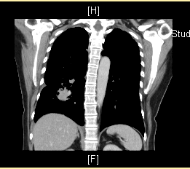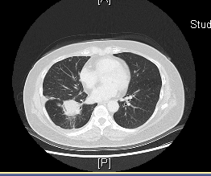

手數日期及方法:
Nil

病理報告:
2023/05/18 PATHOLOGIC DIAGNOSIS:

Adenocarcinoma ---- lung, right, CT-guided biopsy.

GROSS EXAMINATION:
The specimen submitted consists of 7 pieces of tissue, measuring up to 0.3 x 0.1 x 0.1 cm in size. All are embedded for section.

MICROSCOPIC EXAMINATION:
The sections of the specimen show a picture of adenocarcinoma, consisting of clusters of moderately differentiated neoplastic cells in focal glandular pattern and desmoplastic stromal reaction.

The number of tumor cells is more than 100 cells.
細胞學報告:
Nil
治療經過:
This 54 year-old female patient. She admitted on 05/15 due to chronic cough over 6 months, cough especially at night. Mass density over right lower lung, suspect tuberculosis or/and malignancy was diagnosed.
After admission, Arrange chest CT scan showed RLL 4.3cm tumor, highly suspect lung cancer and Left breast nodule (2.1cm). tumor marker-CEA: 290 and CT guided biopsy on 05/18 was arranged for tissure diagnosis and right pneumothorax was found after CT guided biopsy; Suffered from cough as whitish sputum with blood stained and cough with right chest pain, feels more dyspnea in last night, follow up Chest x-ray showed Interval worsening of right pneumothorax, we consulted thoracic surgery and followed up chest sono and pig-tail insertion connect one chest bottle, added LAMA + LABA : Anoro 1puff qd for symptom relief. Arrange Brain MRI and Bone Scan for rumor survey, No evidence of intracranial abnormality and bone metastasis. The 05/18 Chest CT guided biopsy report showed Adenocarcinoma, 申請重大傷病 and delivery EGFR Q-PCR mutation detection, PD-L1 and ROS1 IHC immunohistochemistry examination on 05/20. Due to Chest CT findings left breast nodule (2.1cm), suspected malignancy, consulted Breast surgeon and breast sono was done, biopsy was suggested, but the patient refused to biopsy. Due to the chest x ray showed right pneumothorax is improved, removed right pig tail on 05/24. After treatment, the patient's symptoms improved and the general vital signs were stable. She was discharged then OPD follow up.

