2024年南區胸腔病例討論會
2024 Chest case discussion
課程表
地 點：阮綜合醫院 B棟十樓大教室
地 址：高雄市苓雅區成功一路162號 連絡人：
內科部曾玲雯07-3351121#3075
林莞茹專科護理師07-3351121#2258
場次 | 會議日期 | 時間 | 主持人
1 | 2024年11月13日 | 15:00〜17:00 | 蕭惠元、楊明泉等
2 | 2024年12月11日 | 15:00〜17:00 | 蕭惠元、楊明泉等

主持人
胸腔內科 胸腔外科
蕭惠元 醫師  現職：胸腔內科主任  學歷：  經歷：  阮綜合醫院胸腔科主任 | 楊明泉 醫師  現職：胸腔外科主治醫師  學歷：高雄醫學院醫學系畢業  經歷：  高雄醫學院外科學講師兼胸腔食道外科  心臟血管外科主治醫師、呼吸治療科主治醫師兼主委  阮綜合醫院胸腔血管外科主治醫師兼主任  阮綜合醫院急救加護病房主治醫師兼主任  阮綜合醫院外科部部主任  國立成功大學外科學講師兼胸腔外科主治醫師
  國防醫學院醫學系醫學士
  國立高雄師範大學事業經營學系碩士
  高雄榮民總醫院內科部住院醫師、總醫師
  高雄榮民總醫院胸腔內科總醫師、主治醫師
  高雄榮民總醫院屏東分院胸腔內科主治醫師
梁宇峰 醫師  現職：胸腔內科主治醫師  學歷：高雄醫學院醫學士  經歷：  高雄醫學院醫師  縣立鳳山醫院主治醫師  阮綜合醫院胸腔科主任 | 林鴻生 醫師  現職：胸腔外科主任  學歷：國立陽明大學醫學系畢業  經歷：  高雄榮民總醫院胸腔外科主治醫師  台灣外科醫學會會員  胸腔及心臟血管外科醫學會會員  胸腔暨重症加護醫學會會員
王瑞隆 醫師  現職：胸腔內科主治醫師  學歷：台北醫學大學 醫學系  經歷：  台北馬偕醫院內科住院醫師  林口長庚醫院胸腔科主治醫師  高雄長庚醫院胸腔內科主治醫師  高雄長庚醫院胸腔內科主任  台灣胸腔暨重症加護醫學會理監事 | 戴碩瑩 醫師
  現職：阮綜合醫院胸腔外科主治醫師
  學歷：國立成功大學醫學系
  經歷：
  成功大學醫學院附設醫院胸腔外科總醫師
  台灣外科醫學會專科
  台灣胸腔及心臟血管外科專科
  台灣肺癌醫學會專科
林安伸 醫師
現職：胸腔內科主治醫師
學歷：中國醫藥大學醫學系
經歷：
林口長庚紀念醫院內科部住院醫師
長庚紀念醫院胸腔內科總醫師
高雄長庚醫院胸腔內科主治醫師
2024年南區胸腔病例討論會
摘要課程表
地 點：阮綜合醫院 B棟十樓大教室
地 址：高雄市苓雅區成功一路162號 連絡人：
內科部曾玲雯07-3351121#3075
林莞茹專科護理師07-3351121#2258
場次 | 會議日期 | 時間 | 主持人
1 | 2024年11月13日 | 15:00〜17:00 | 蕭惠元、楊明泉等
2 | 2024年12月11日 | 15:00〜17:00 | 蕭惠元、楊明泉等
場次2
15：00-15：30討論病例
Name: xx 三進
Age : 69 year-old
Gender: male
Chart NO: 1306219
C/C : mild cough for long terms
Past history :
1.Squamous cell carcinoma of R/T muccal mucosa,cT3N1M0, s/p wide excision on 2009/09/03, pT3N0M0,margin 5 MM,LN 0/33,4.1 CM, MUSCLE(+), S/P post R/T for 54 GY TILL 2009/12/4
2016/11/04 92001C 99
2017/01/06 92001C 99
2017/02/06 92001C 99
2017/11/06 92001C 99
2018/02/07 92001C 99
2018/06/22 92001C 99
2018/09/03 92001C 99
2018/09/19 92014C 25
家族史：
Nothing particular
旅遊史：
T.O.C.C:
T國外流行地區旅遊史：無
O職業：無
C動物接觸史：無
C是否群聚：無
個人病史：
[Personal History]--> Occupation:Others Education:senior-high Marital status:married Exercise:no
Alcohol:occasional or social Tobacco:occasional Coffee:occasional Tea:occasional
Diabetes mellitus:denied
Hypertension:denied
Reflux esophagitis,erosive gastritis,duodenal ulcer with stenosis of PR with regular OPD F/U at our hospital.
Operation history:scalp tumor post excision on 94/10/6
Travel history:nil
No liver diseases, hypertension, CVA, Diabetus Mellitus, TB, arthritis for family history
家族史：
Family history:
- Month : nil
- Heart disease: nil
- Renal disease: nil
- HBV/HCV: nil
- Pulmonary disease: nil
- Cancer : nil
- Hypertension: nil
- Diabetes Mellitus: nil
個人病史：
[Personal History]-->
Education:junior-high
Marital status: Marital
Exercise:no
Alcohol:no
Tobacco:no
Coffee: no
Tea: no
Betel nut: no
T: travel history: denied. in recent three months
O: occupational hitory: 退休
C: contact history: denied
C: cluster history: denied

理學發現：
[Vital Sign]
--> BH:164.5cm BW:.63.3kg
Temp:36.5C BP:130/79mmHg
PR:675/min RR:18 /min
[General appearance]
--> Consciousness:alert GCS:(E4V5M6 )
Development:normal
Nourishment:well
[Ear]
--> EEC:clear
Hearing:normal
[Throat]
--> Tonsil:normal
Tongue:normal
Pharynx:normal
[Nose]
--> Discharge:no
Smelling:normal
[Thyroid]
--> Size:non-palpable Nodule:non Tender: -

[Eye]
--> Conjunctiva: not anemic
Sclera: not icteric
Pupil size, R't: 2mm Pupil size, L't: 2mm
Light reflex (R/L):+/+ Shape:regular
[Lymph Node]
--> Cervical:non palpable
Axillary:non palpable
Inguinal:non palpable
Consistency:soft
[Chest]
--> Contour:normal
Percussion:reasonant
Breathing sound: clear
Heart beat:regular
Heart sound:no murmur
[Abdomen]
--> Liver: non palpable
Spleen: non palpable
Mass:no
Tenderness:no
Bowel Sound:normal
Rigidity:non
Ascites:non
Distension:no
Hernia:normal
[Spine & Extremities]
--> Spine:normal
Upper extremities:normal
Lower extremities:normal
Nail:normal
入院經過:
A 69 year-old male case has had the past history of:1. Squamous cell carcinoma of R/T muccal mucosa,cT3N1M0, s/p wide excision on 2009/09/03, pT3N0M0, margin 5 MM,LN 0/33,4.1 CM, MUSCLE(+), S/P post R/T for 54 GY TILL 2009/12/4~with regualr Our OPD f/u; 2. hypertension with regular our OPD f/u. His ADL status was totally independent. TOCC:(-).
According to patient's statement, he had suffered from dyspnea, cough with massive whitish sputum in recent months. He was routine follow-up chest image and Chest CT on 11/30 revealed in favor of lung cancer in the left upper lobe with suspected left hilar lymphadenopathy. T2aN1. D/D: TB, fungal infection, etc. ; physical examination and associated symptoms, There was no fever,chill, headache, poor appetite, nasal obstruction, chest tightness, cold sweating, bloody or tarry stool passage, flank pain, burining urination, frequency and no body weight loss. Under above problems, he was admitted for further evaluation and management.
<<active problem>>
一般檢查：
 | 2023.12.05
CEA | No test | ng/ml
特殊檢查及處置：
2023/12/5 Chest AP Supine
Cardiomegaly.
Atherosclerosis of aorta.
No obvious bony lesion.
No widening of mediastinum.
LUL mass.
Post-inflammatory fibrosis at right upper lung.
Spondylosis.
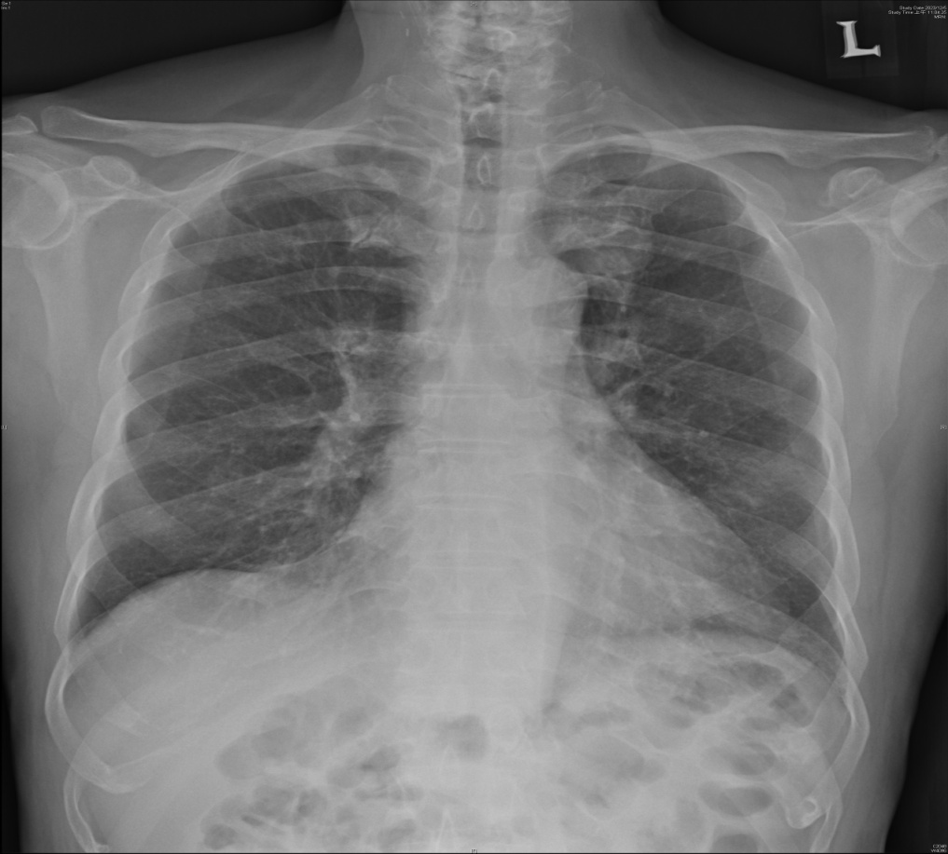

2023/11/30 CT-CHEST
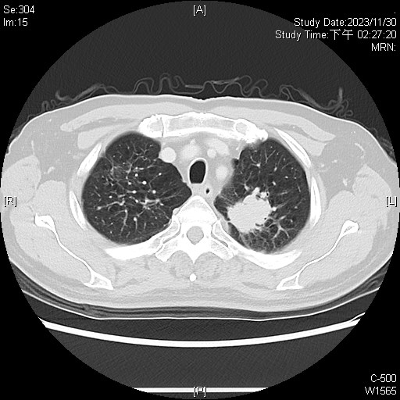

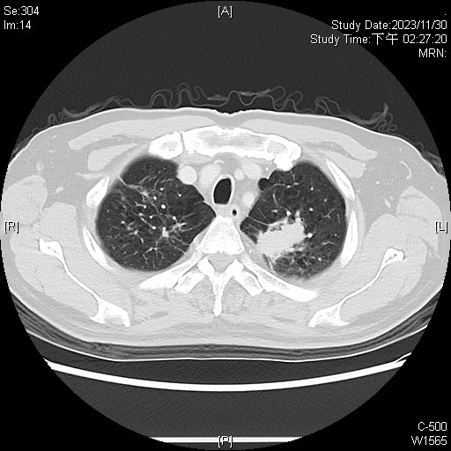
Imaging Report Form for Lung Carcinoma_肺癌(AJCC 8th edition)
Without contrast enhancement.
1.Imaging Date
2023/11/30 Date of examination (Y/M/D)
Imaging Modality
Imaging by (v) CT scan () MRI
Imaging Protocol

2.Tumor location
Location:
() Right Upper Lobe () Right Middle Lobe () Right Lower Lobe
(v) Left Upper Lobe () Left Lower Lobe () Other
Size:
(v) Measurable: _3.4__cm (greatest dimension)
() Non-measurable
3.Tumor invasion
() No or Equivocal
(v) Yes, if yes:
() Tumor ≦ 3cm () Tumor ≦ 1cm
() Surrounded by lung or visceral pleura () 1cm < Tumor ≦ 2cm
() Not more proximal than lobar bronchus () 2cm < Tumor ≦ 3cm
-------------------------------------------------------------------------
(v) 3cm< Tumor ≦ 5cm
() Involves main bronchus, ≧ 2cm from carina (v) 3cm < Tumor ≦ 4cm
() Invades visceral pleura () 4cm < Tumor ≦ 5cm
() Focal atelectasis or obstructive pneumonitis to hilum
-------------------------------------------------------------------------
() 5 cm < Tumor ≦ 7cm
() Invades chest wall, diaphragm, mediastinal pleura, parietal
pericardium
() Tumor in the main bronchus (<2cm from carina)
() Atelectasis of entire lung
() Separate tumor nodule(s) in same lobe
-------------------------------------------------------------------------
() Tumor > 7 cm
() Invades mediastinum, heart, great vessels, trachea, recurrent
laryngeal nerve, esophagus, vertebral body, carina
() Separate tumor nodule(s) in a different lobe of the ipsilateral
lung.
4. Regional nodal metastasis
() No or Equivocal
(v) Yes, if yes, location (specified as below):
[(v) Ipsilateral hilar lymph nodes () Contralateral hilar
lymph nodes () Ipsilateral mediastinal and/or subcarinal
lymph nodes () Contralateral mediastinal lymph nodes
() Ipsilateral or contralateral supraclavicular lymph nodes]
5.Distant metastasis (In this study)
(v) No or Equivocal
() Yes, if yes:
[Thoracic:
() Separate tumor nodule(s) in a contralateral lobe
() Tumor with pleural nodules or malignant pleural
(or pericardial) effusion
Extrathoracic : ______________(specify location)]
() Single meta. in a single organ
() Multiple Meta. in a single or multiple organs
6.Other findings:
Calcied plaques along the left anterior descending artery.
Gall stones.
Bilateral renal cysts
IMP:
1. In favor of lung cancer in the left upper lobe with suspected left hilar lymphadenopathy. T2aN1.
D/D: TB, fungal infection, etc.
2. Atherosclerosis of left anterior descending artery.
3. Gall stones.
4. Bilateral renal cysts.
2023/12/19-> PET/CT
＜＜Image Findings＞＞
1. A pulmonary tumor with increased FDG uptake in the LUL (3.9cm, SUVmax: early 12.61, delayed 14.35).
2. Symmetrically and mildlly increased FDG uptake in the bilateral pulmonary hilar lymph nodes (SUVmax: early 2.80, delayed 3.02).
3. Pulmonary infiltrations and fibrosis with mildly increased FDG uptake in the RUL (SUVmax: early 1.14, delayed 1.40).
4. Increased FDG uptake in the prostate (SUVmax: early 3.64).
《Impression》
1. Primary lung cancer in the LUL is compatible.
2. Favor reactive lymph nodes in the bilateral pulmonary hilar regions. D/D: metastasis.
3. Favor mild inflammation in the RUL.
4. Increased FDG uptake in the prostate. It can be BPH or prostate cancer. Suggest GU OPD for further evaluation.
5. The staging according to F-18 FDG PET/CT is T2aN0M0 (8th AJCC system).
2023/12/25->Brain MRI without contrast Impression--
1. Old left globus pallidus lacunar infarction
2. Old left midbrain lacunar infarctions
3. Right fetal-origin PCA
4. Mild atrophy of the cerebrum
5. Right maxillary sinusitis
2023/12/29
Bronchoscopic Diagnosis：the closure of left upper lobe bronchus by srgery
IV Bronchoscopic Findings：
A.Vocal cords ：no check
B.Trachea ：some sputum
C.Carina ：normal
D.Bilateral main bronchus and bronchi：
Left main: peterchia and submucosal hemorrhage
LUL: closed by external compression. surgical resection
LLL: normal
RM: normal
RUL: some sputum
RI: normal
RLL and RML: normal
1.Bronchial brushing and washing were done from：none
2.Biopsy was done from：none
Examiner: 林鴻生 Checker: 林鴻生
手術日期及方法：
Re admission on 2023/12/25 for Adenocarcinoma of lung, LUL, T2aN0M0 , surgical lobectomy of lung, LUL,
病理報告：
2023/12/06-> PATHOLOGIC DIAGNOSIS:
Adenocarcinoma and see description ---- lung, left, CT-guided biopsy.
GROSS EXAMINATION:
The specimen submitted consists of four pieces of tissue, measuring up to 0.4 x 0.1 x 0.1 cm in size. All are embedded for section.
MICROSCOPIC EXAMINATION:
The sections of the specimen show a picture of adenocarcinoma, consisting of clusters of moderately differentiated neoplastic cells in solid and cribriform pattern. The tumor cells are positive for CK7 stain but negative for TTF-1 stain. Either primary lung adenocarcinoma or metastasis is considered in histology. Suggest clinical correlation.

The number of tumor cells is more than 100 cells.

Pathologist:傅婷瑛醫師
病解專醫字第0385號

15：30-16：00討論病例
Name:李XX
Age : 59 year-old male
Chart NO: 1675845
C/C : cough and body weight loss on 2-3 months (72-->55kg)

Past history :
1.Hypertension(-)
2.Type II diabetes mellitus:(+)
3.Hepatitis-B(-),Hepatitis-C(-)
4.Operation/ admission history:
1.Low abdominal pain, suspect pancreatitis in 2020/11

家族史：
Denied family history of Hypertension, Type 2 diabetes mellitus, CAD, CKD, cancer

旅遊史：
TOCC:
Travel history in recent 3 months ago: denied
Occupation: denied
Contact history: Animal contact history: denied, Illness contact history: denied
Cluster: no family and friend with the similar symptoms

個人病史：
[Personal History]--> Occupation:Worker
Education:junior-high
Marital status:single
Exercise:no
Alcohol:quit
Tobacco:quit
Coffee:no
Tea:no
Betel nut:quit
Drugs:no
Allergy:never 敘述:NKA
動物接觸史:無

理學發現：
[Vital Sign]--> BH:166 cm BW:65 kg Temp:37.1 度C BP:170/118 mmHg
PR:102 /min RR:18 /min
[General appearance]--> Consciousness:alert GCS:(E4V5M6 ) Development:normal Nourishment:well
[Ear]--> EEC:clear Hearing:normal TM:not-test
[Throat]--> Tonsil:normal Tongue:normal Pharynx:normal Mouth floor:normal
[Nose]--> Discharge:no Smelling:normal
[Thyroid]--> Size:non-palpable Nodule:non Tender:+
[Eye]--> Conjunctiva:not anemic Sclera:not icteric
Pupil size, R't:3mm Pupil size, L't:3mm
Light reflex (R/L):+/+
[Lymph Node]--> Cervical:non palpable Axillary:non palpable
Inguinal:non palpable Consistency:soft
[Ophthalmosopic]--> Ophthalmoscopic:not-test
[Neck]--> Neck:supple
[Chest]--> Contour:normal Percussion:reasonant Breathing sound:clear
Heart beat:regular Heart sound:no murmur
[Abdomen]--> Liver:non palpable Spleen:non palpable Mass:no Tenderness:no
Bowel Sound:normal Rigidity:non Ascites:non Distension:no
Hernia:normal
[Genitalia]--> Genitalia:not-test
[Rectal]--> Anus:not-test DRE:not-test
[Spine & Extremities]--> Spine:normal Upper extremities:normal
Lower extremities:normal Nail:normal

入院經過 :
The patient was admitted to our ward on 2024/02/26 due to cough and body weight loss on 2-3 months (72-->55kg), chest x-ray found RLL mass and admdission for biopsy.
After admission, CT guided biopsy for RLL mass on 2/29, examination was arrange as abdominal sono, head MRI and chest CT. Impression of Favor lung cancer in the right lower lobe with left supraclavicular and bilateral mediastinal lymph node metastases, malignant pericardial effusion, liver metastases and suspected left renal metastasis. T2bN3M1c. Pathology report revealed Non-small cell lung carcinoma, possible large cell neuroendocrine carcinoma. Port-a implantation on 2024/03/07 and chemotherapy since with #Etoposide inj. 100mg/5mL/vial(Fytosid) 128.80 on 3/8 ~ 3/10 and cispltin 96.60mg on 3/8. Post-chemotherapy, condition stable, patient was discharged and OPD follow up prescribed.
一般檢查:
2024/02/29-> Na ： 136 meq/L ; K ： 3.3 meq/L ; WBC ： 8.2 10 ^3/uL ; RBC ： 3.81 10 ^6/uL ; Hb ： 12.2 g/dL ; Hct ： 34.8 % ; Platelet ： 379 10^3/uL ; MCV* ： 91.3 fL ; MCH ： 31.9 pg ; MCHC* ： 34.9 g/dL ; RDW ： 14.4 % ; MPV ： 6.2 fl ;
2024/02/26-> GOT ： 17 U/L ; GPT(ALT) ： 10 U/L ; BUN ： 5 mg/dL ; Cre(B) ： 0.57 mg/dL ; eGFR ： 146.3 ml/min/1.73 m^2 ; Na ： 134 meq/L ; K ： 2.9 meq/L ; WBC ： 7.7 10 ^3/uL ; RBC ： 4.27 10 ^6/uL ; Hb ： 13.6 g/dL ; Hct ： 38.5 % ; Platelet ： 391 10^3/uL ; MCV* ： 90.2 fL ; MCH ： 31.9 pg ; MCHC* ： 35.3 g/dL ; RDW ： 14.6 % ; MPV ： 6.5 fl ; Neutrophil ： 70.4 % ; Lymphocyte ： 14.5 % ; Monocyte ： 11.8 % ; Eosinophil* ： 3.0 % ; Basophil* ： 0.3 % ; PT ： 11.0 sec ; PT (INR) ： 1.07 INR ; PT (Ctrl) ： 12.2 ; APTT ： 34.7 sec ; APTT (Ctrl) ： 30.9 sec ;

特殊檢查及處置：
2024/02/26 Brain MRI
- Normal brain parenchyma
2. Bilateral fetal-origin PCA
3. Atherosclerotic narrowing in the proximal basilar artery
4. Bilateral maxillary sinusitis

2024/02/27 Chest CT without and with contrast
1. In favor of lung cancer in the right lower lobe with left supraclavicular and bilateral mediastinal lymph node metastases, malignant pericardial effusion, liver metastases and suspected left renal metastasis. T2bN3M1c.
2. Atherosclerosis of left anterior descending artery.
3. Degenerative change of T-spine.

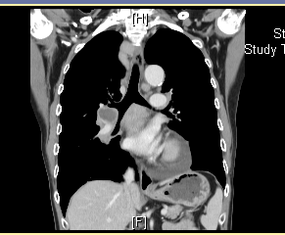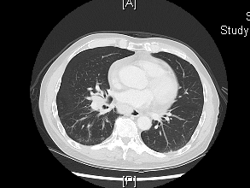

手數日期及方法:
Port-A implantation on 2024/03/07
病理報告:
2024/02/29 PATHOLOGIC DIAGNOSIS:
Non-small cell lung carcinoma, possible large cell neuroendocrine carcinoma --- lung, CT-guided biopsy

GROSS EXAMINATION:
The specimen submitted consists of three pieces of tissue, labeled lung, measuring up to 0.3 x 0.1 x 0.1 cm in size.
All are embedded for sections.

MICROSCOPIC EXAMINATION:
The sections show a picture of non-small cell carcinoma, consisting of solid nests of non-small neoplastic epithelial cells with hyperchromatic nuclei and moderate amount of cytoplasm. Prominent tumor necrosis is noted. Neither mycobacteria nor fungi can be identified in the acid fast and PAS stains. The tumor cells show positive for CK, INSM-1, and synaptophysin, and negative for TTF-1, p40, and CD68 immunostains. Based on the morphology and immunostaining results, large cell neuroendocrine carcinoma is considered first.
Note: Adequate tumor cells present (>= 100 viable tumor cells): Yes

細胞學報告:
Nil

治療經過:
The patient was admitted to our ward on 2024/02/26 due to cough and body weight loss on 2-3 months (72-->55kg), chest x-ray found RLL mass and admdission for biopsy.
After admission, CT guided biopsy for RLL mass on 2/29, examination was arrange as abdominal sono, head MRI and chest CT. Impression of Favor lung cancer in the right lower lobe with left supraclavicular and bilateral mediastinal lymph node metastases, malignant pericardial effusion, liver metastases and suspected left renal metastasis. T2bN3M1c. Pathology report revealed Non-small cell lung carcinoma, possible large cell neuroendocrine carcinoma. Port-a implantation on 2024/03/07 and chemotherapy since with #Etoposide inj. 100mg/5mL/vial(Fytosid) 128.80 on 3/8 ~ 3/10 and cispltin 96.60mg on 3/8. Post-chemotherapy, condition stable, patient was discharged and OPD follow up prescribed.

16：00-16：30討論病例
Name: 簡XX
Age : 42 year-old female
Chart NO: 2539592
C/C : Left upper back mass note for one month

Past history :
Rheumatoid arthritis for years medication control
Type 2 Diabetes Mellitus(-)
Hypertension(-)
Hyperlipidemia(-)
Cancer(-)
Hepatitis B/C carriers (-)
Chronic/Tumors/Cancers/Genetic diseases (-)
Current medication :
慢性處方箋 次數：2024/01/09/ 0000 ~ 2024/4/2 ( Dr.孫俊明 )
Celecoxib 200mg/cap(Celebrex) 1.00 cap BID PC
Hydroxychloroquine 200mg/tab(Plaquenil) 1.00 tab BID PC
#Methotrexate 2.5mg/tab(Methotrexate) 6.00 tab QW PC
Folic acid 5mg/tab(Folic acid) 1.00 tab QD PC
Leflunomide 20mg/tab(Arheuma) 1.00 tab Qd PC

Operation/hospitalization history:
YGH: Left posterior chest wall tumor s/p excision on 113/03/02 under GA

家族史：
Denied family history of Hypertension, Type 2 diabetes mellitus, CAD, CKD, cancer

旅遊史：
TOCC:
Travel history in recent 3 months ago: denied
Occupation: worker (全聯)
Contact history: Animal contact history: denied, Illness contact history: denied
Cluster: no family and friend with the similar symptoms

個人病史：
[Personal History]-->
Occupation:Worker
Education:college
Marital status:single
Exercise:no
Alcohol:no
Tobacco:no
Coffee:no
Tea:no
Betel nut:no
Drugs:Others
Allergy:never ,藥物:NKA
動物接觸史:無

理學發現：
[Vital Sign]--> BH:166 cm BW:54.5 kg Temp:36.3 度C BP:125/71 mmHg
PR:75 /min RR:17 /min
[General appearance]--> Consciousness:alert GCS:(E4V5M6 )
Development:normal Nourishment:well
[Ear]--> EEC:clear Hearing:normal TM:intact
[Throat]--> Tonsil:normal Tongue:normal Pharynx:normal Mouth floor:normal
[Nose]--> Discharge:no Smelling:normal
[Thyroid]--> Size:non-palpable Nodule:non Tender:-
[Eye]--> Conjunctiva:not anemic Sclera:not icteric
Pupil size, R't:2mm Pupil size, L't:2mm
Light reflex (R/L):+/+ Shape:regular
[Lymph Node]--> Cervical:multiple Axillary:non palpable
Inguinal:non palpable Consistency:soft
[Ophthalmosopic]--> Ophthalmoscopic:no test
[Neck]--> Neck:supple
[Chest]--> Contour:normal Percussion:reasonant
Breathing sound:clear Heart beat:regular
Heart sound:no murmur
[Abdomen]--> Liver:non palpable Spleen:non palpable Mass:no Tenderness:no
Bowel Sound:normal Rigidity:non Ascites:non Distension:no
Hernia:normal
[Genitalia]--> Genitalia:no test
[Rectal]--> Anus:no test DRE:no test
[Spine & Extremities]--> Spine:left upper back tumor Upper extremities:normal
Lower extremities:normal Nail:normal

入院經過 :
According to the patient . A 42 -year-old female who has a history of Rheumatoid arthritis for years medication control . She suffered from left upper back mass note for one month . In the beginning, she did not pay attention to it. However, the mass bigger than before . The associated symptoms were including loss 2kg in half year. shortness of breathing sometime . The symptoms persisted for one month, and aggravating ; therefore, admitted to ER. The followings are physical examination findings : patient is alert; has clear breathing sound, no icteric sclera, soft abdomen. Four extremities are muscle power 5/5 . The MRI received left posterior chest wall tumor (8.2*3.8*11.8 cm). D/D: soft tissue sarcoma, metastasis, etc. Under the impression of left posterior chest wall tumor , she was admitted for further survey and treatment.
一般檢查:
2024/03/05-> CA 72-4 ： 30.20 U/mL ;
2024/03/01-> GOT ： 9 U/L ; GPT(ALT) ： 6 U/L ; ALP ： 32 U/L ; Bil(T) ： 0.29 mg/dL ; Bil(D) ： 0.07 mg/dL ; TP ： 5.6 g/dL ; Alb ： 3.65 g/dL ; BUN ： 9 mg/dL ; Cre(B) ： 0.59 mg/dL ; eGFR ： 111.8 ml/min/1.73 m^2 ; WBC ： 6.0 10 ^3/uL ; RBC ： 3.52 10 ^6/uL ; Hb ： 12.0 g/dL ; Hct ： 34.8 % ; Platelet ： 220 10^3/uL ; MCV* ： 98.7 fL ; MCH ： 33.9 pg ; MCHC* ： 34.4 g/dL ; RDW ： 14.1 % ; MPV ： 7.7 fl ; Neutrophil ： 68.4 % ; Lymphocyte ： 14.2 % ; Monocyte ： 11.8 % ; Eosinophil* ： 5.2 % ; Basophil* ： 0.4 % ; PT ： 10.9 sec ; PT (INR) ： 1.06 INR ; PT (Ctrl) ： 12.4 ; APTT ： 33.1 sec ; APTT (Ctrl) ： 30.3 sec ; CEA ： 1.9 ng/ml ; AFP ： 2.0 ng/ml ; CA-199 ： 3.30 U/ml ; CA-153 ： 5.4 U/ml ; SCC ： 0.7 ng/ml ; CA-125 ： 56.8 U/ml ;

特殊檢查及處置：
2024/03/01 Chest CT without and with contrast
1. Enhanced soft tissue at left lateral back (infrascapular, submuscular region; ~8x3x10 cm3 @Se/Im:4/42). Nature to be determined.
DDx: soft tissue sarcoma, elastofibroma dorsi, metastasis, etc. Suggest further study.
2. Hypovascular nodule at S5 of liver (1.7cm @Se/Im:4/63).
3. Nodular ground-glass opacity at RLL of lung (0.75cm @Se/Im:6/54).
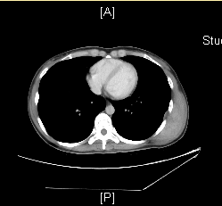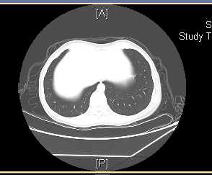
手數日期及方法:
s/p excision of the chest wall tumor , left on 2024/03/14

病理報告:
2024/03/15 PATHOLOGIC DIAGNOSIS:
Desmoid fibromatosis --- chest wall, left, excision

GROSS EXAMINATION:
The specimen consists of one piece of soft tissue, labeled chest wall, left, measuring 13 x 12.8 x 10 cm in size.
Representative parts are submitted for sections in five blocks

MICROSCOPIC EXAMINATION:
The sections of the specimen show a picture of desmoid fibromatosis, composed of long, sweeping fascicles of bland fibroblasts and myofibroblasts with hyalinized area and gaping thin-walled blood vessels. There is infiltration of adjacent skeletal muscle tissue. The peripheral margin is free of tumor.

細胞學報告:
Nil

治療經過:
The patient was admitted to our ward on 2024/03/13 forsurgicalintervention under the impression of Left posterior chest wall tumor, suspect sarcoma or metastasis. During the hospitalization, surgical excision of the chest wall tumor , left on 2024/03/14. Post operation, proper wound care was given. Painkiller was prescribed for pain control. Empirical antibiotics was used for cefazolin 1gm q8h. Due to stable clinical course, patient was discharged and OPD follow up prescribed.

