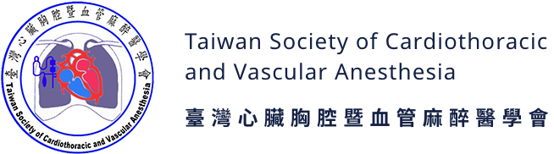**j**

**臺灣心臟胸腔暨血管麻醉醫學會血液動力學工作坊**

TSVCTA Hemodynamic Monitoring Workshop

主辦單位：臺灣心臟胸腔暨血管麻醉醫學會、亞東醫院麻醉部

協辦單位：台灣愛德華生命科學股份有限公司

日 期：113年05月 04（星期六）09:00~15:20

地 點：臺北新板希爾頓酒店會議室3F會議室1-3

學分申請: 臺灣心臟胸腔暨血管麻醉醫學會、台灣麻醉醫學會、

台灣外科醫學會、台灣胸腔及心臟血管外科學會、

台灣內科醫學會、中華民國心臟學會

中華民國重症醫學會、台灣術後加速康復學會

|  |  |  |  |  |
| --- | --- | --- | --- | --- |
| Time | Topic | | Speaker | Moderator |
| 09:00-09:30 | Registration | |  | |
| 09:30-09:40 | Opening | | 林子玉 理事長 | |
| 09:40-10:30 | Minimally invasive hemodynamic monitoring in cardiovascular and thoracic surgery | | 張國珍 醫師 | 陸正威 部長 |
| 10:30-11:20 | Cardiac ERAS + HPI | | 陳哲伸 主任 |
| 11:20-12:10 | Monitoring Brain Oxygenation: A Critical Component of Anesthesia Management and Patient Safety | | 丁乾坤 主任 |
| 12:10-13:30 | Lunch | |  | |
|  | **Simulation/Hands-on Training Stations (每站 30 分鐘)**  **Event Organizer: 簡維宏 主任** | | | |
|  | Station 1  Achieving Immediate Extubation and Optimal Recovery: FEMH's Journey of ERAS Cardiac with  Multimodal Analgesia and Comprehensive Monitoring  施乃文 醫師 | Station 2  Comprehensive Hemodynamic with CO & StO2  (題目暫定)  劉孟琦主任 | Station 3  Cardiogenic Shock management of Cardiac Patient  (題目暫定)  簡維宏 主任 | |
| 13:30-14:00 | **A** | **B** | **C** | |
| 14:00-14:30 | **C** | **A** | **B** | |
| 14:30-15:00 | **B** | **C** | **A** | |
| 15:00-15:20 | Closing Remarks and Photo | | | |

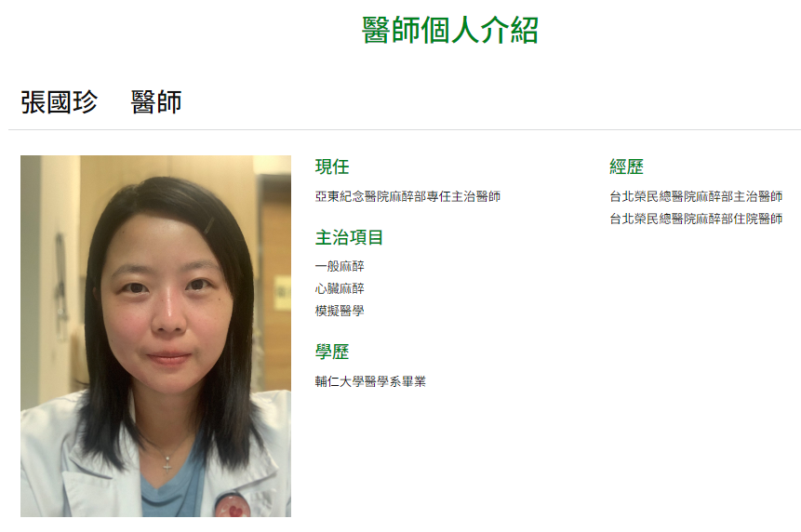

**Minimally invasive hemodynamic monitoring in cardiovascular and thoracic surgery**

Through surgical hemodynamic performance and how to monitor whether the patient's treatment is smooth and whether the prognosis is rapid recovery, the current medical team is multiplied and cooperates with the professional assessment of this department to provide appropriate diagnosis and treatment. Treatment recommendations, especially in cases of open heart surgery and cardiovascular surgery, are most important to monitor hemodynamics.

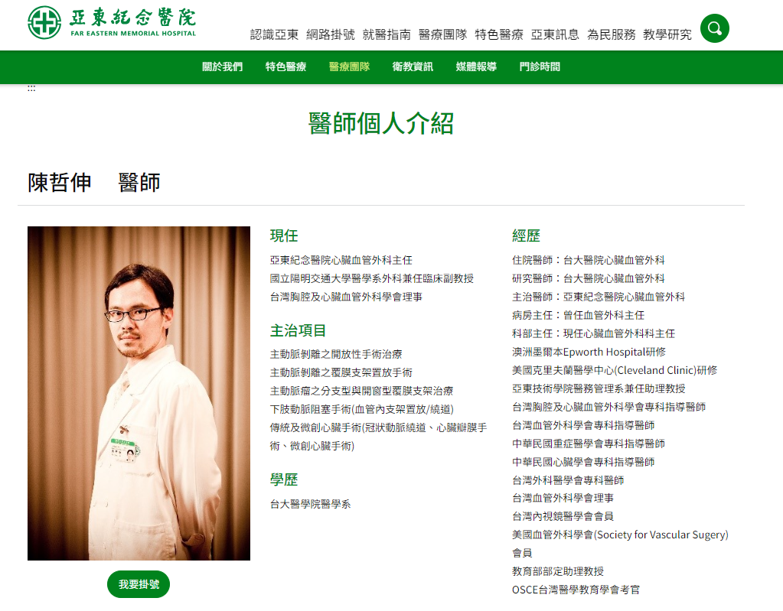

**Cardiac ERAS + HPI**

Enhanced Recovery After Surgery (ERAS) is a bundled approach to perioperative care based upon the philosophy that patients do better when emotional and physiologic stresses are minimized during surgery. The goal of ERAS is to return patients to normal functional status as quickly as possible.

The hypotension prediction index (HPI) monitor. (Edwards Lifesciences, Irvine, CA) is a novel device that uses. machine learning to develop an algorithm that integrates select. parameters from the arterial pressure waveform to predict the. likelihood of a hypotensive event.

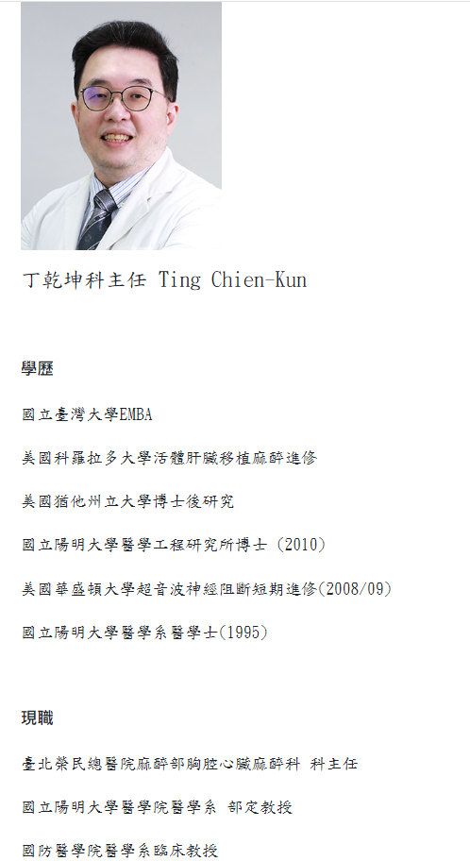

**Monitoring Brain Oxygenation: A Critical Component of Anesthesia Management and Patient Safety**

Over the past few years, the use of non-invasive neuromonitoring in non-brain injured patients has increased, as a result of the recognition that many of these patients are at risk of brain injury in a wide number of clinical scenarios and therefore may benefit from its application which allows interventions to prevent injury and improve outcome.

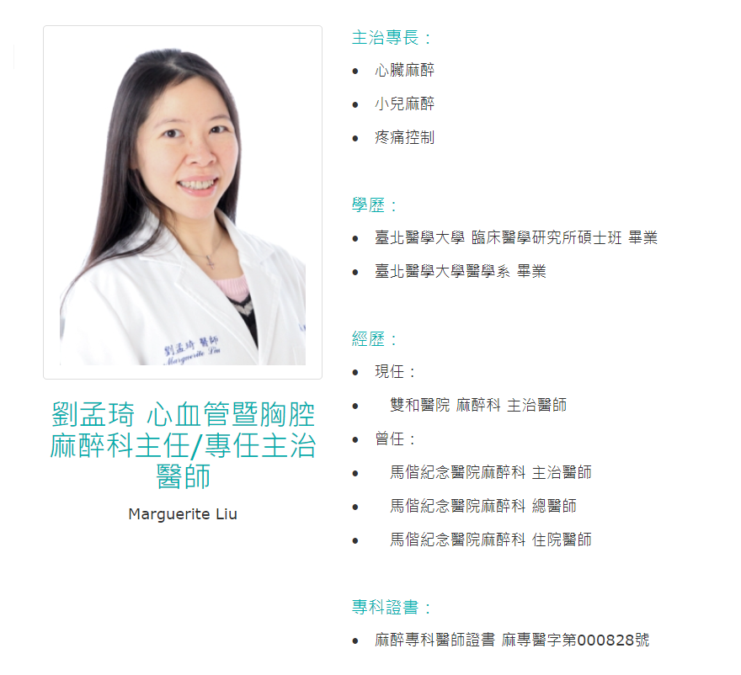

Station 2

**Comprehensive Hemodynamic with CO & StO2**

Comprehensive hemodynamics is an important part that cannot be ignored in anesthesia and surgical treatment. The concentration of CO & StO2 in the patient's blood and the proportion of anesthetic drugs affect the patient's vital signs and even more clinical possibilities. This course You can learn how to interpret the patient's condition and how to deal with the situation.

*經社群驗證圖示*

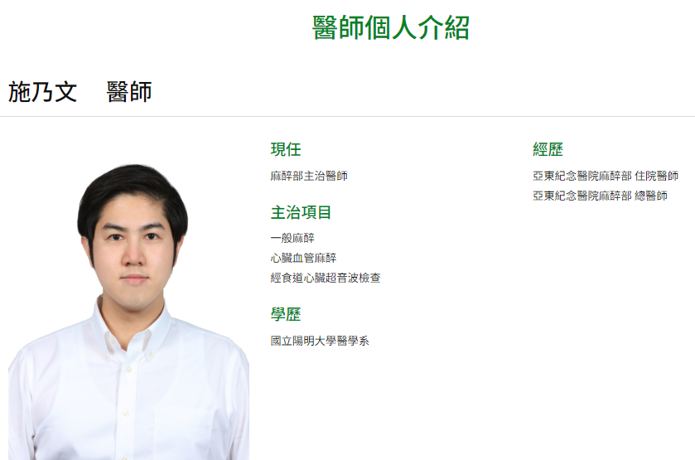

Station 1

**Achieving Immediate Extubation and Optimal Recovery: FEMH's Journey of ERAS Cardiac with Multimodal Analgesia and Comprehensive Monitoring**

After treatment, patients are worried about the prognosis and subsequent treatment. Even during post-treatment monitoring and observation, they will need more sophisticated instruments or a more accurate medical team to discuss the diagnosis and give the most appropriate treatment and drugs; through FEMH's Journey, we can effectively reduce If the patient is in pain, the tube can be extubated more accurately and in advance, so that the prognosis and recovery status can be adjusted to the best possible state.

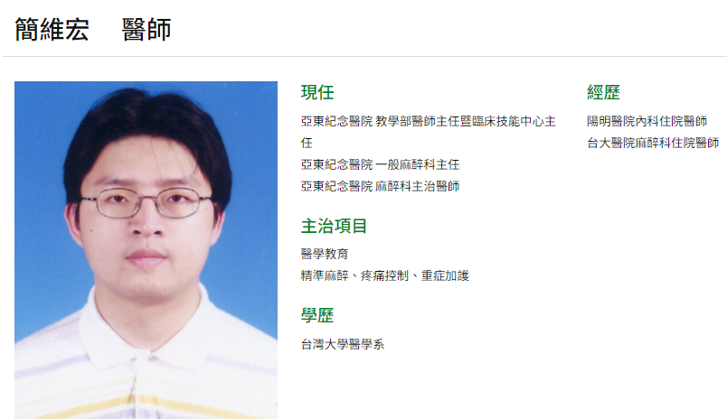

Station 3

**Cardiogenic Shock management of Cardiac Patient**

Clinical manifestations and diagnostic interpretation of patients with cardiogenic shock during treatment or non-treatment. Even if cardiogenic shock occurs during treatment, how to deal with it clinically. This course explains the clinical occurrence and treatment. Find real cases for explanation and discussion.